Ideation Phase
Brainstorm & Idea Prioritization Template

Date | 28 February 2026
Team ID | LTVIP2026TMIDS43269
Project Name | Flight Finder: Navigating Your Air Travel options
Maximum Marks | 4 Marks

1.1 Empathy Map Canvas
This step defines who we are building for and what their experience is like. We are focusing on our primary user, "The Frequent Traveler."
A. User Persona: The Frequent Traveler
B. Target Audience: Users aged 20-50, who travel for business or leisure at least 3 times a year.
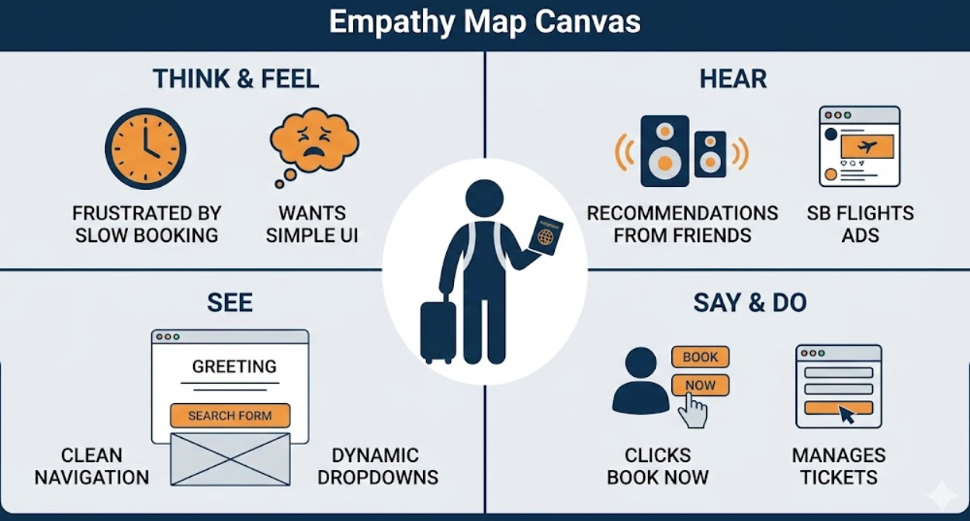
Empathy Map Canvas Diagram
A diagram illustrating an Empathy Map Canvas for 'The Frequent Traveler', divided into four quadrants labelled 'THINK & FEEL', 'HEAR', 'SEE', and 'SAY & DO'. In the centre, a simplified traveller icon holding a passport. THINK & FEEL shows Pains like 'FRUSTRATED BY SLOW BOOKING' and 'WANTS SIMPLE UI'. HEAR shows 'RECOMMENDATIONS FROM FRIENDS' and 'SB FLIGHTS ADS'. SEE shows a simple UI wireframe with 'GREETING'.

Step 2: Low-Fidelity Wireframes
The most important screen for John is the landing page. We must design the interface that supports the requirements we brainstormed, including dynamic dropdowns and the search function. This low-fidelity wireframe will show the layout.
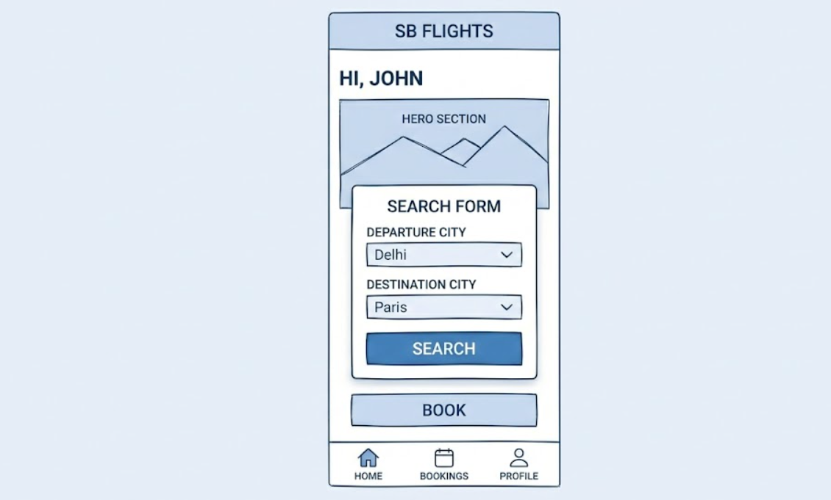
Low-Fidelity Landing Page Wireframe
A wireframe sketch (using sketch-lines, shades of blue, and white) of the SB Flights app landing page on a mobile screen. At the top, the 'SB FLIGHTS' header and the greeting 'HI, JOHN'. A main central card contains the 'SEARCH FORM'.

1.2 Brainstorming- Idea Generation & Prioritization
Category | Matter
Ideas Generated | High Fidelity Mock-ups for dynamic city dropdowns  Interactive maps showing flight routes
Prioritized Ideas | High Priority (Must-Have): Mobile-responsive UI using Bootstrap, Personalized dashboard for user bookings, Dynamic city dropdowns

Prioritization Matrix for SB Flights
A diagram illustrating the prioritization of ideas generated for the SB Flights application, designed as a continuation of the prioritization logic shown in image_0.png and the wireframe in image_1.png. A matrix divides ideas into four quadrants using a feasibility (low to high) and impact (low to high) axis.
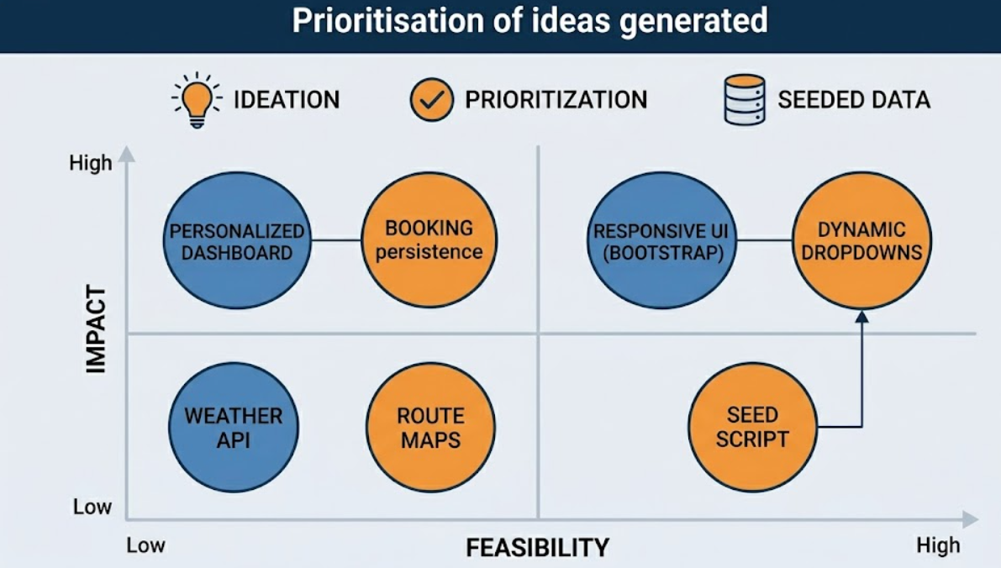

Step 3: Define Problem Statements
This section clearly defines the specific problems the development team will address, summarizing the empathy and brainstorming.
Category | Matter
Problem Statement 1 | Frequent travellers face an unreliable and frustrating flight booking experience on many platforms. Users [The Frequent Traveler], who want a complex-free interface, are struggling to book quickly because many current travel applications are slow, slow-responsive, or not mobile-first.
Problem Statement 2 | Developing the 'SB Flights' dynamic city dropdowns is complex because the database must be seeded with static data. This requires a dedicated seed script that can delete previous data and insert new flight details (e.g., Delhi to Paris) automatically.
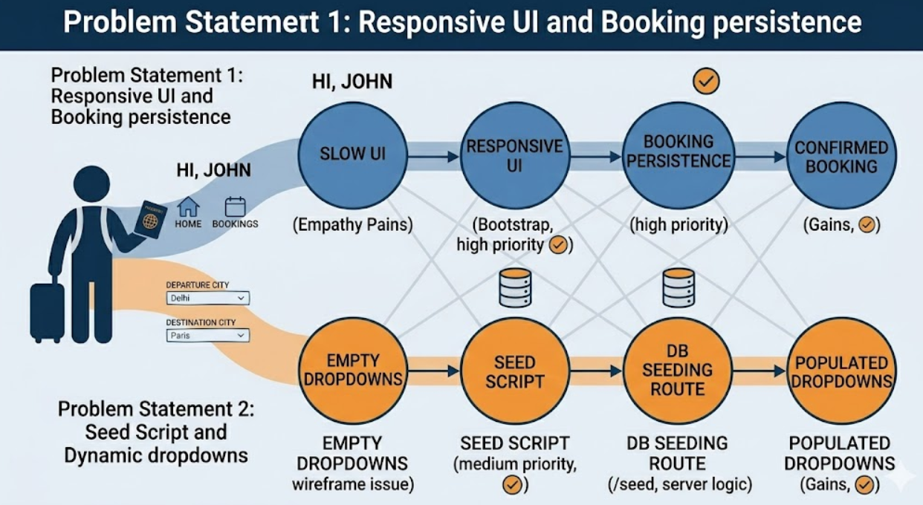
Problem Statement Mapping for SB Flights

